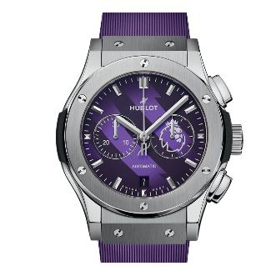

**Product Name:**

**Hub lot Classic Fusion Chronograph Titanium Purple**

**Description:**

A luxury wristwatch featuring a **striking purple dial and strap**, encased in **titanium** for durability and a sleek appearance. The **chronograph function** includes three sub-dials for precise timekeeping. The bezel is secured with **six screws**, adding to the watch's robust design. A **date window** is positioned at the 6 o’clock mark.

**Specifications:**

* **Case Material:** Titanium
* **Dial Color:** Purple
* **Strap Material:** Rubber
* **Functions:** Chronograph, Date
* **Movement:** Automatic
* **Water Resistance:** 50 meters

**Price:**

**$10,000 to $15,000 USD**